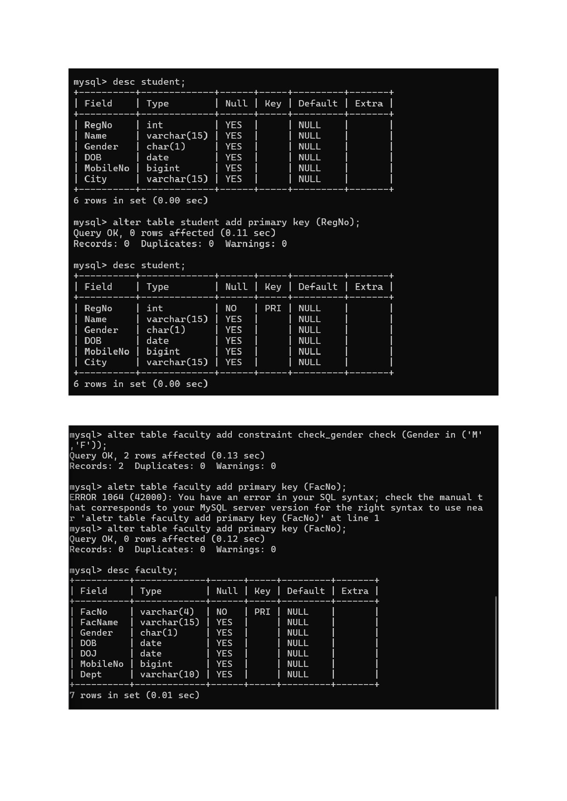
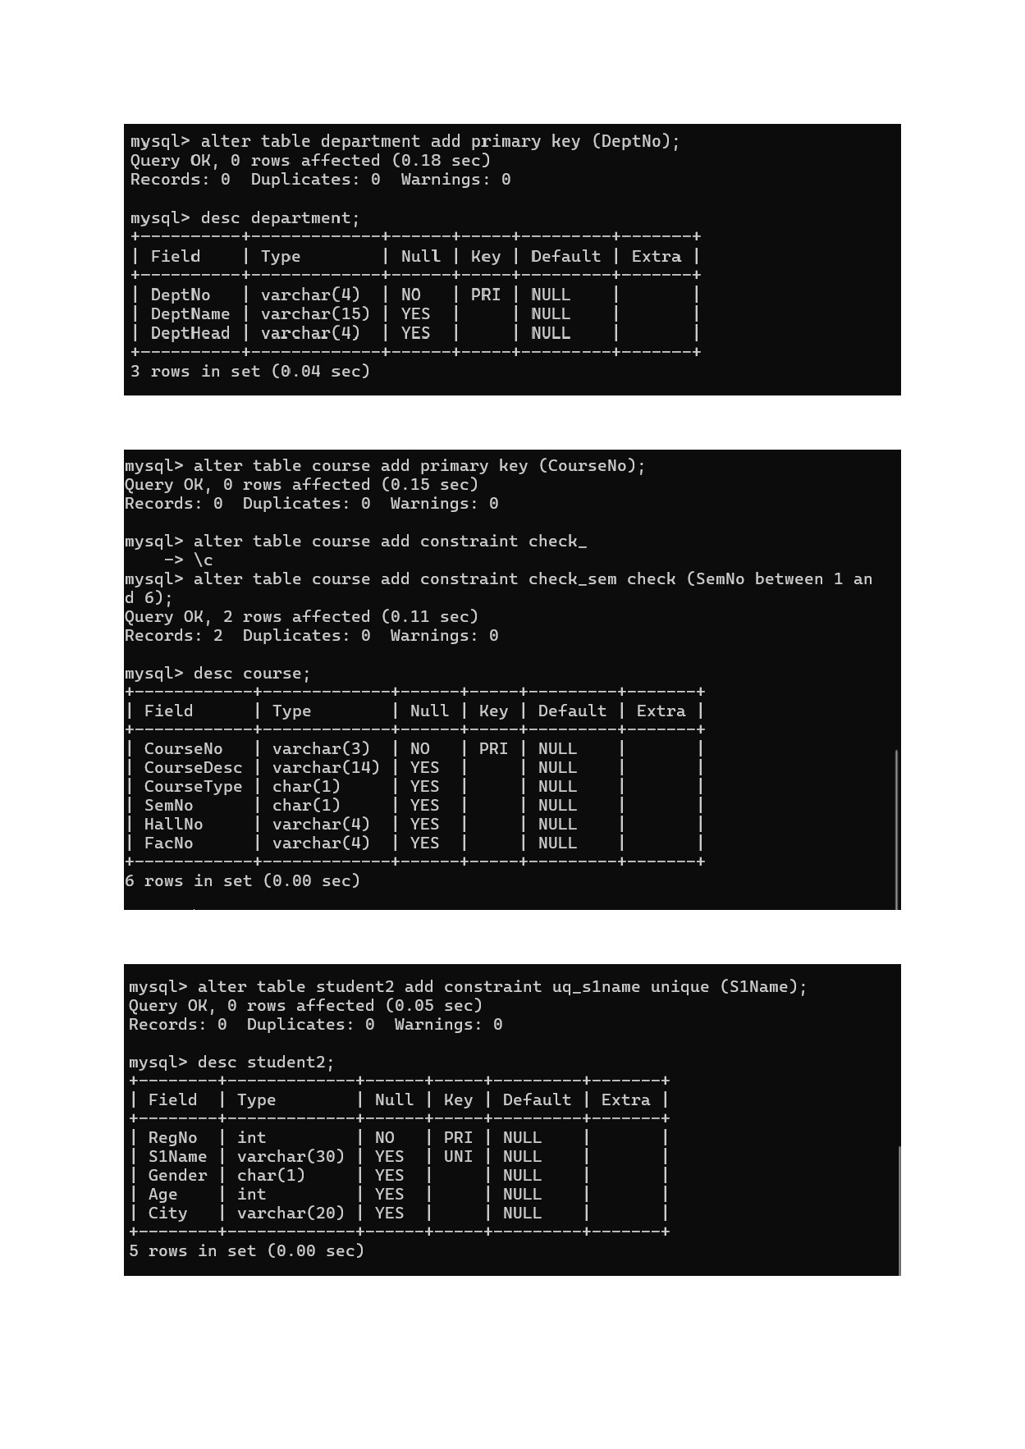

mysql> INSERT INTO student2
-> VALUES (101, 'Allen' , 'F' 20 'Chennai'); Query Ok, 1 row affected (0.04 sec)
mysql> INSERT INTO student3
-> VALUES (101, 'DBMS' , 95); Query Ok, 1 row affected (0.04 sec)
mysql> ^{A} C mysql> INSERT INTO student3
-> VALUES (999, 'DBMS' , 90);
ERROR 1452 (23000): Cannot add or update a child row: a foreign key constrai nt fails ('experimentl' . 'student3' , CONSTRAINT '+k_regno' FOREIGN KEY ('RegN o') REFERENCES 'student? ('RegNo'))

